Plants and the
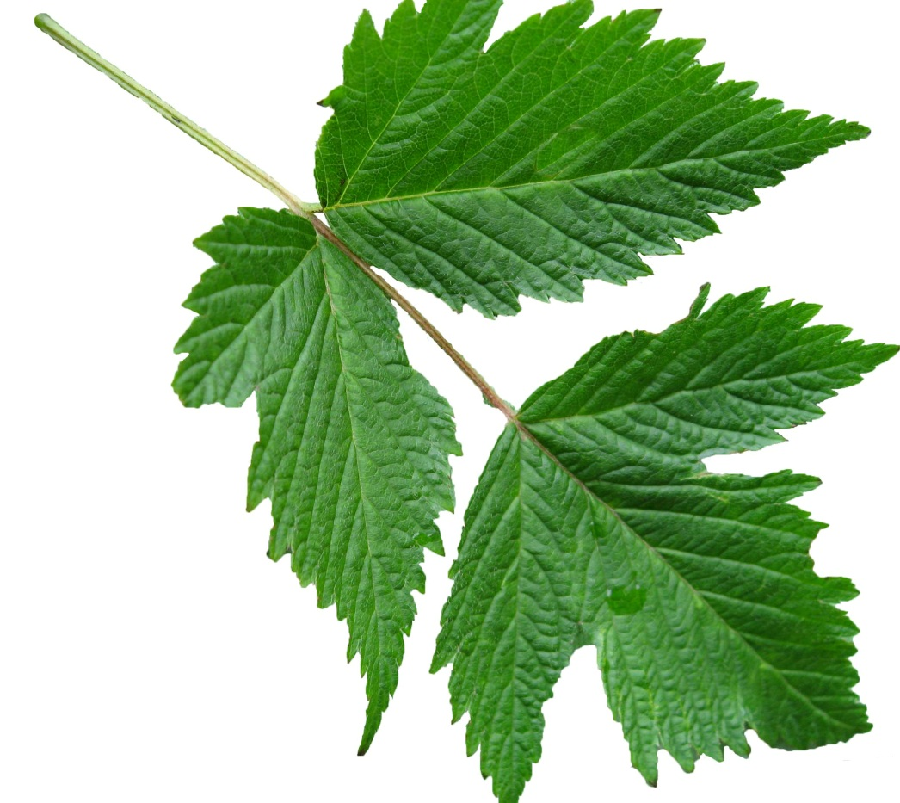
Carbon Cycle
Student
Handouts

How seeds grow to trees
and plants transform Carbon

The Environmental Literacy Project
Carbon: Transformations in Matter and Energy
(Carbon TIME)
2011-2012

Plant Growth Investigation-- Procedures

Materials
- 4 aluminum cups
- 4 Handi-wipe strips “wicks”
- 1 ½ to 2 cups Vermiculite
- 80 Radish seeds
- Digital Scale
- 1 empty cup or container (for measuring mass of seeds only)

Setting Up Procedures

- Obtain 4 small aluminum cups. Using a Sharpie marker, label each cup with your group name/number. Then label one cup for each condition: - Day 7 Light -Day 7 Dark
- Day 14 Light -Day 14 Dark

- Using scissors, make a ½ inch slit in the bottom of each of your cups. Insert 1 wick into the slit so that half of the wick is on the inside of the cup and half is outside the cup. This wick will keep your plant supplied with water from the bottom of the cup.

- Place the Day 7 Light aluminum cup on the digital scale, then zero out the scale. Add vermiculite to the cup to be about 2/3 full. Write down the start mass of the vermiculite in your data table. Repeat this step for the other three cups. Make sure to record the mass of the vermiculite in your data table for each one (the mass will be slightly different for each cup).

- Count out 20 seeds. Place an empty container on the scale and zero out the scale. Then add the 20 seeds to the empty container to get the mass of the seeds. Record the start mass for the seeds in your table for the Day 7 Light condition.

- Plant the seeds in the vermiculite for this cup. Place the seeds just under the surface of the vermiculite.

- Repeat steps 4 and 5 for the other three cups.

- Once you have measured mass of the seeds and planted them in the vermiculite, place your aluminum cups on trays designated by your teacher. Make sure you place the “LIGHT” cups on the trays that will be in the light and the “DARK” cups on the trays that will be in the dark.
Harvesting Your Plants

Materials
- 2 Small paper bags
- Clean surface
- Digital scale
- Weigh boats or empty containers

Procedures For Day 7

- Label one of your paper bags with your group name/number and Day 7 LIGHT. Label the other bag with group name/number and Day 7 DARK.

- Place the Day 7 LIGHT set up (cup, vermiculite, plants, wick, everything!) in the labeled paper bag. Fold the top of the bag and staple once.

- Repeat step 2 for the DARK set up.

- Give both bags to your teacher for drying overnight.

- Once dried you will need to separate your plant material from your vermiculite. Pour the contents of your LIGHT bag onto a clean surface. Sort all plant material from the vermiculite.

- Place an empty container onto the digital scale and zero out the scale. Place all the plant material into the container. Record the plant end mass on your data table.

- Place another empty container onto the digital scale and zero out the scale. Place all the vermiculite into the container. Record the vermiculite end mass on your data table.

- Repeat Steps 5-7 for your DARK bag, recording the end mass for your Day 7 Dark plants and vermiculite in your data table.

Procedures For Day 14

- Repeat all the steps for your Day 7 plants, this time measuring the mass of your Day 14 plants grown in the light and dark.

- Once all plant material and vermiculite is massed, calculate the mass change for each of your 4 cups.

- Describe your results for plants grown in the light and plants grown in the dark in the space provided on your observation sheet.

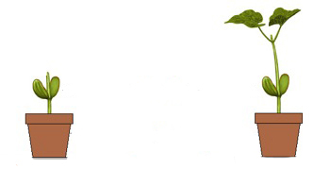
1690’s
STUDY #2
5 Years Later
Plant mass = 5 pounds
Soil mass = 200 pounds

Plant mass = 169.3 pounds
Soil mass = 199 pounds

Let’s travel back in time 360 years. It is now the year 1642. We are in Europe. It is a time of excitement and exploration. More people are getting interested in finding out about the world around us. We are going to meet one of these early scientists. He is a doctor but he also does experiments with plants. His name is Jan Baptiste vanHelmont. Dr. van Helmont was very interested in what plants took in from the soil. Almost everyone back in 1642 thought plants gained weight from the soil. van Helmont did an experiment to see if this was true. He planted a 5-pound young willow tree in a bucket containing 200 pounds of soil. He watered the tree regularly but he did not add any more soil to the bucket. After 5 years he weighed the willow tree and bucket again. van Helmont’s results are below:

STUDY #1
1640’s
Conclusion: vanHelmont concluded that the willow tree must get most, or even all, of its nutrition and mass from WATER. How does his evidence support his conclusion?
In the 1690’s a scientist named John Woodward decided to test van Helmont’s findings to see if water was the only source of nutrition for plants. Woodward grew spearmint plants in different types of water, and over the course of several months he monitored how well the plants grew. Some of the spearmint plants were placed in regular river water, some had river water plus soil minerals added, and some were grown in water with no minerals (distilled). He also measured water given off by the plant compared to how much mass was gained—this is the transpiration ratio. Woodward’s results are below:

Water Source% biomass gainTranspiration RatioRiver water #1100111River water #212695River water + soil minerals #122264River water + soil minerals #230953Distilled water (no minerals)36215
Conclusion: Woodward concluded that plants actually get a little mass from minerals and water, but most water is given off by plants and does not add mass.
Famous Studies of Plants

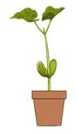
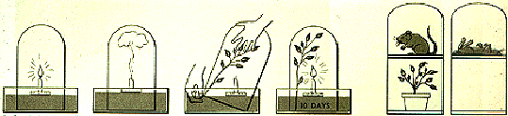
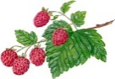
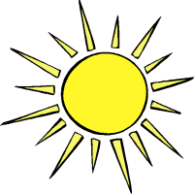
1780’s-1790’s
Conclusion: Senebier concluded that some mass of plants must come from gases in the air. He thought plants took the carbon out of carbon dioxide, and gave off the extra oxygen.
CO₂
C
O₂
AIR
STUDY #4
1770’s
Let’s go forward 100 years. It is now the late 18th century, a time of revolution in America and Europe. A scientist named Joseph Priestley is doing a series of tests to see if plants get anything from the air. At this time scientists did not know about oxygen or carbon dioxide, but they knew living things needed air to survive and that fire also needed air. Dr. Priestley placed a burning candle in a container with a plant, sealed the container so no air could get in or out, and eventually the candle went out. After several days, he used a mirror outside the container to light the candle, and the candle lit. Dr. Priestley also placed a mouse in a sealed container with little oxygen and a mouse in a sealed container with little oxygen and a plant. The mouse in the container with the plant lived. The other mouse was not so lucky!
STUDY #3
Conclusion: Priestly concluded that plants replenished the air so candles and living organisms can breathe, so plants change the air around them.
Scientists started to find that air was a mixture of different gases, including oxygen and carbon dioxide. Many scientists knew that plants gave off oxygen, but it was Jean Senebier who found that plants also take in carbon dioxide while they give off oxygen (when placed in the light). Senebier did many studies to show this, but in one study Senebier placed raspberry leaves in a sealed container with extra carbon dioxide. He placed the sealed container in the light from 7 a.m. to 6 p.m. for 6 days. He then measured the amount of oxygen after 6 days and found it was higher than the amount of oxygen in normal air. Carbon dioxide was lower than in normal air.
Oxygen: 18%
Carbon Dioxide: 6%

Nutrients For Plants
Bottled Water—H₂O
Fat……………..….0%
Sodium…………...0%
Carbohydrates…..0%
Protein…………...0%
Atoms:
HYDROGEN
OXYGEN
WATER
Natural Minerals/Fertilizers
Nitrate (NO₃⁻)
Phosphate (PO₄⁻⁻⁻)
Other soil minerals: Potassium, iron, copper, magnesium, zinc, etc.
Major Atoms:
NITROGEN
PHSOPHORUS
OXYGEN
POTASSIUM
IRON

SOIL MINERALS

Oxygen
Hydrogen
Nitrogen
Carbon
Air Molecules
Nitrogen (N₂)………..….78%
Oxygen (O₂)……….……..21%
Argon…………….……..0.93%
Carbon Dioxide (CO₂).0.003%
Water vapor (H₂O) …0 to 3%

Major Atoms:
NITROGEN
OXYGEN
ARGON
CARBON
HYDROGEN

AIR

Atoms:
CARBON
OXYGEN
HYDROGEN

Some NITROGEN in proteins
Carbohydrate Molecule: Starch
PLANTS
Peas
Fat…………..……8%
Sodium…………..0%
Carbohydrates…66%
Protein………….26%

What Is Photosynthesis?

We’ve heard that plants need sunlight to grow. Scientists have conducted experiments to see why sunlight is important for plants. These experiments have shown that plants grow better when they have light than when they do not have light. Have you seen evidence to support these findings?

Sunlight is a form of energy, but it is not a material. So sunlight cannot add matter to a plant. Sunlight does have something very important to do with plant growth though. Scientists have found that plants are able to do something with the sun that no humans or other animals are able to do:
Plants can use sunlight to make their own food in their leaves.

So how do plants make their own food? Do you have a guess?

We all know that plants need sunlight, water, soil, minerals, and air to grow, but of these things, which add mass to the plant? Which give the plant atoms that they use to build their body structures—branches, leaves, flowers—to grow?
Oxygen
Carbon
Hydrogen
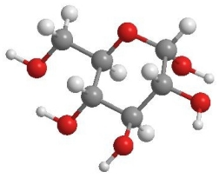
Think back to what you learned from the nutrition labels for water, carrots, and apple juice. Plants are made of materials that could not come from water or soil. These materials are carbohydrates (like sugar), fats, and proteins. Look at the sugar molecule on the right. It has carbon, hydrogen, and oxygen atoms. Where do plants get these atoms?

While soil and minerals are things plants need, they do not add a lot of mass to plants. Have you collected or seen evidence to support this? Soil and minerals also do not give plants the carbon, hydrogen, and oxygen atoms they need. But there are other things plants take in that give them these atoms. In order for plants to make their own food, they need three ingredients: water, carbon dioxide, and sunlight. Two of these are forms of matter and one is a form of energy.

Matter. Carbon dioxide is a gas that is in the air. Carbon dioxide gas enters the leaves through tiny holes in the leaves. Have you seen evidence that plants take in carbon dioxide? Plants also take in water from the soil. The water travels from the roots up tubes inside the plant. Some water gives atoms to the plant to build biomass, but MOST water just adds short-term mass to the plant.
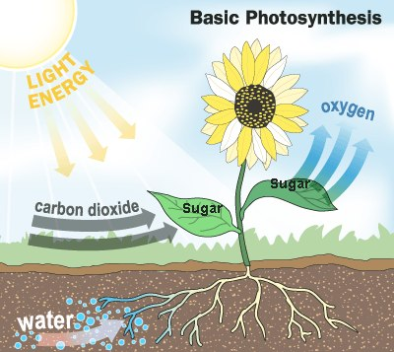
Energy. Sunlight is light energy that can be absorbed in the leaves of plants. Some cells in the leaves are able to trap the sun’s energy in the leaf. And guess what? The plants use the sun’s energy to combine the water and carbon dioxide to make food!

Photosynthesis
When carbon dioxide, water, and light energy are in the leaf cells, the cells go through a process in order to make food. This process is called photosynthesis. “Photo” means light and “synthesis” means putting together. Photosynthesis is using sunlight to combine carbon dioxide (CO₂: carbon and oxygen atoms) and water (H₂O: hydrogen and oxygen atoms) in order to make sugar (or glucose). The cells in plants also give off oxygen gas as a waste product because they do not need all the oxygen atoms. So plants cells rearrange the carbon, hydrogen, and oxygen atoms from carbon dioxide and water into sugar and oxygen!
Sometimes scientists use an equation to represent how this happens. The equation for photosynthesis is:
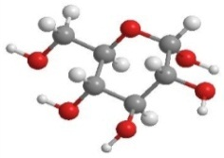
MATTER: 6 water (H₂O) + 6 carbon dioxide (CO₂) → sugar (C₆H₁₂O₆) + 6 oxygen (O₂)

ENERGY: light energy → chemical energy

Many things can happen to the sugar that plants make. This sugar travels from the leaves to all other parts of the plant, where it can be used by plant cells. This is the only way cells in the roots or the stems or the flowers can get the sugar they need. When plants store food, they usually change it from sugar to some other kinds of food, such as starches. All the food on Earth started out as sugar made by plants!

Modeling Photosynthesis Instructions

In your groups, you will use molecular model kits to model the process of photosynthesis. You will build the materials that go into the plant cells, and then use the models to show how those materials change inside cells. The equation for photosynthesis is:
MATTER: 6 water (H₂O) + 6 carbon dioxide (CO₂) → sugar (C₆H₁₂O₆) + 6 oxygen (O₂)

ENERGY: light energy → chemical energy

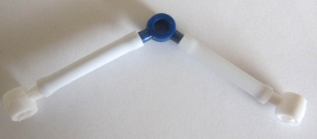
This means that 6 water molecules combine with 6 carbon dioxide molecules to form 1 glucose molecule and 6 oxygen molecules. In order to model photosynthesis, you will first need to build your carbon dioxide and water molecules.

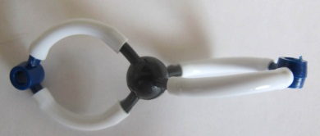
Step 1: Build Your Water Molecules: Water contains 1 oxygen atom and 2 hydrogen atoms. Build 6 of these molecules.

Step 2: Build Your Carbon Dioxide Molecules: Carbon dioxide contains 1 carbon atom and 2 oxygen atoms. There are two bonds between the carbon atom and oxygen atoms (called a “double bond”). Build 6 of these molecules.

Step 3: Answer Questions About Your Reactants: Look at your water and carbon dioxide molecules. Using your worksheet, answer the questions about these two molecules in Part 2. What atoms do these molecules have, and do they have chemical energy?
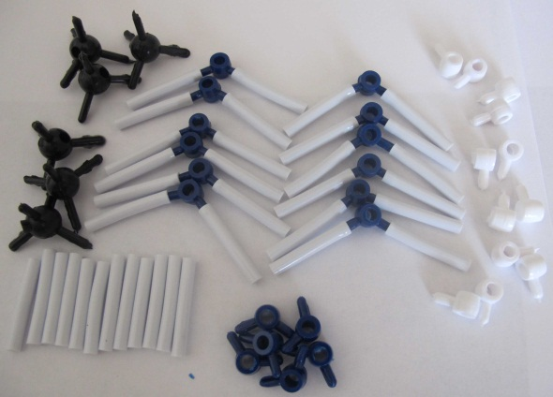
Step 4: Photosynthesis Happens: In photosynthesis, plant cells break down CO₂ and H₂O and rearrange the atoms into glucose and oxygen. Take apart all the atoms and bonds of your CO₂ and H₂O.
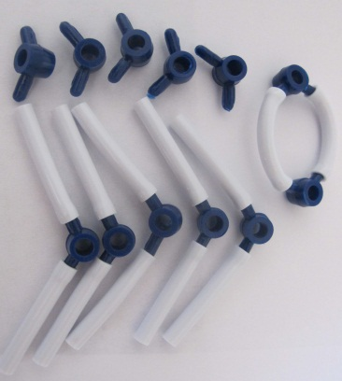
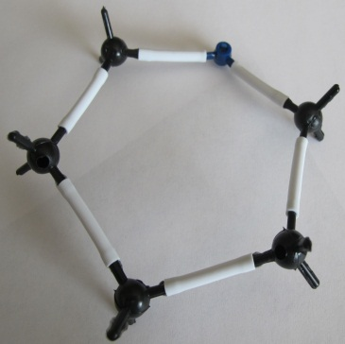
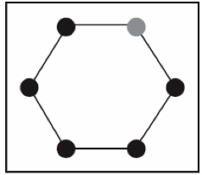
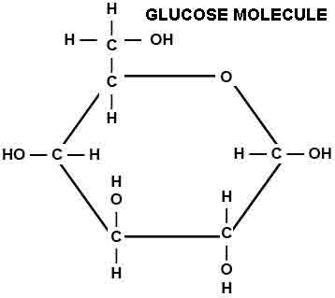
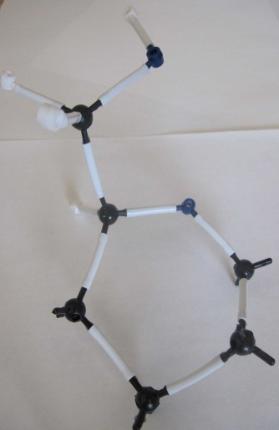
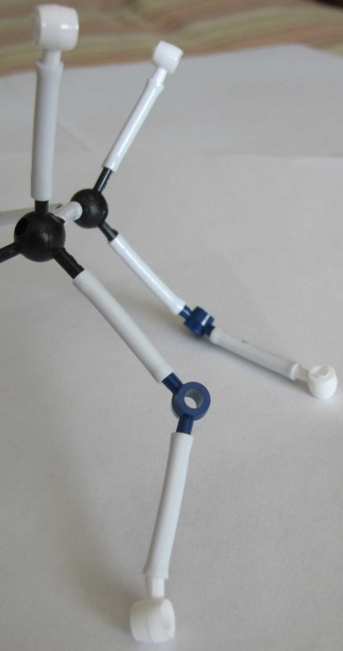
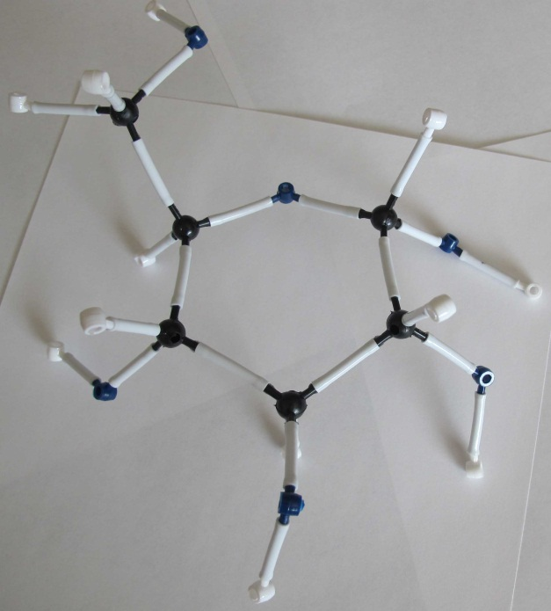
Step 5: Make Your Oxygen Molecules: Assign one person in your group to start working on the oxygen molecules. This person will take the oxygen atoms (originally from water molecules) and 6 of the oxygen atoms from carbon dioxide and make 6 oxygen molecules. Oxygen is 2 oxygen atoms connected using a double bond.

Step 6: Make Your Glucose Molecule: The rest of the group should work on the glucose molecule. First make the “glucose ring,” which is made of 5 carbon atoms and 1 oxygen atom connected to form a circular shape.

Next add the CH₂OH group. You will work with the carbon that is to the left of the oxygen in your ring. On this carbon, connect a second carbon. On the second carbon, attach 2 hydrogen and 1 oxygen atom. Attach another hydrogen to the oxygen. Then attach 1 hydrogen to the carbon that is on the ring.

Move to the other four carbons on the ring. Attach 1 oxygen and 1 hydrogen to these carbons. Then attach another hydrogen to each oxygen. Make sure it looks similar to the image on the right.

Now, answer and discuss the questions on your worksheet.
What Is Cellular Respiration In Plants?

Some people may think plants and people are exact opposites—that people breathe in oxygen and breathe out carbon dioxide, while plants do the reverse. They may also think that plants “breathe out” oxygen for people to use. This is not the whole story!

You have learned that plants make sugar through the process of photosynthesis. They take in sunlight to combine water and carbon dioxide to make glucose. Glucose is made mostly of carbon, hydrogen, and oxygen atoms, and is food for plants because it has chemical energy.

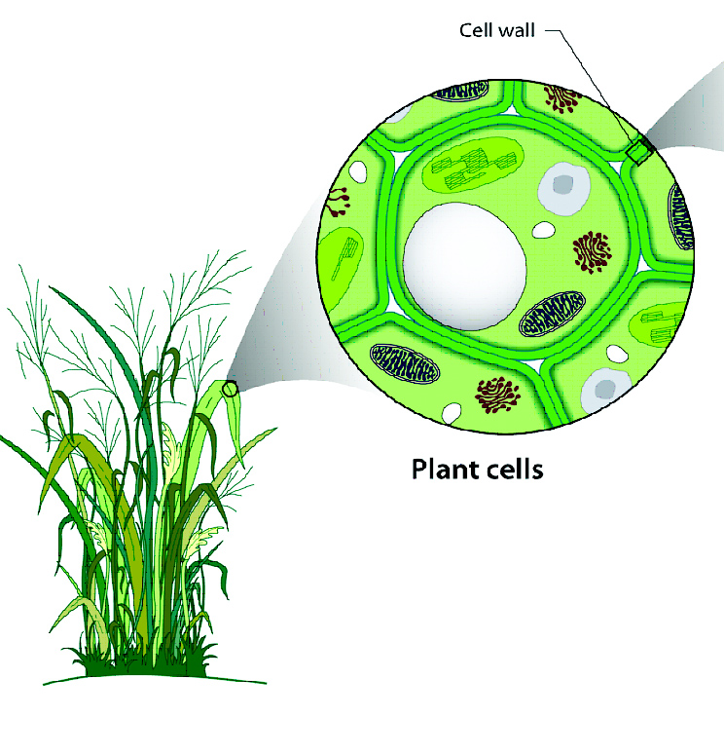
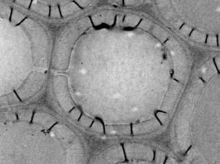
Plants make energy-rich glucose for a reason. Plants have cells and internal systems just like people have cells and internal systems. People need a constant supply of chemical energy (food) to keep their bodies working, and plants need the same thing. The glucose plants make in their leaf cells is transported to all the cells in the plant. This sugar travels to all parts of the leaves, stems, roots, and flowers.
2 micrometers (10⁻⁶)
Microscopic Scale
1 meter (10¹)
Macroscopic Scale

Once the glucose reaches all the cells in the plant, plants either incorporate the glucose into more complex molecules, like starch, cellulose, or lignin; or plants use the glucose to power their life processes. Just like burning a marshmallow changes chemical energy to light and heat, plants cells do a similar thing to sugar when they need usable energy.
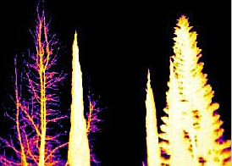
Infrared Image of Plants at Night
Plants use glucose for power by converting the chemical energy in food to other forms of energy. A plant may change chemical energy into motion energy or heat. Several examples of things plants use energy to do include transporting sugar from leaves to cells, carrying out biosynthesis and cell division (in other words, growing), and moving (e.g., in response to light). Plants also give off heat!

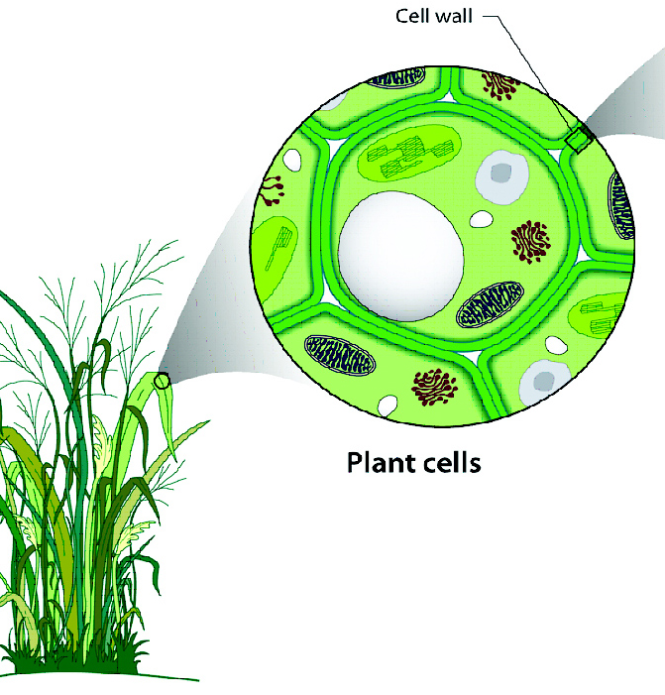
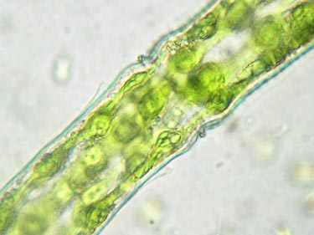
So how do plants convert the chemical energy in glucose into usable forms of energy? They do this by oxidizing the glucose. Just like when you burn a marshmallow or candle and both need oxygen to burn, the plant cells also use oxygen to break up the glucose molecule. The plant transports glucose and oxygen to its cells, and then the two react.
100-500 picometers(10⁻¹⁰)
Atomic-Molecular Scale
GLUCOSE
OXYGEN
WATER
CARBON
DIOXIDE
1 Meter (10⁰)
Macroscopic Scale
2 micrometers (10⁻⁶)
Microscopic Scale
10⁻⁸

MATTER: Glucose(C₆H₁₂O₆) + 6Oxygen(O₂) → 6Carbon Dioxide(CO₂) + 6Water (H₂O)

ENERGY: chemical energy → kinetic energy + heat

So, plants also take in and use oxygen just like people do! When glucose reaches the cells, and reacts with oxygen, the cells change chemical energy into other forms. They give off carbon dioxide and water as waste products, just like people do! So plant cells use cell respiration to get energy! Plant cells use the energy in food to perform important life processes. Without food
and oxygen a plant’s cells would not be able to do cell respiration and would not survive.

Modeling Cellular Respiration Instructions

In your groups, you will use molecular model kits to model the process of cellular respiration. You will build the materials that go into the cells, and then use the models to show how those materials change inside cells. The equation for cellular respiration is:

MATTER: Glucose(C₆H₁₂O₆) + 6Oxygen(O₂) → 6Carbon Dioxide(CO₂) + 6Water (H₂O)

ENERGY: chemical energy → kinetic energy + heat

This means that a glucose molecule reacts with 6 oxygen molecules to form 6 carbon dioxide molecules and 6 water molecules. In order to model cellular respiration, you will first need to build your glucose and oxygen molecules.
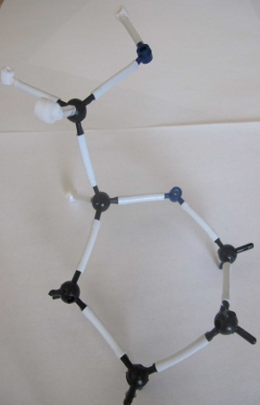
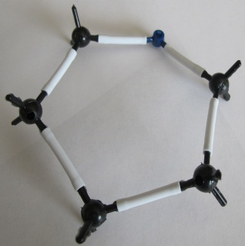
Step 1: Make Your Oxygen Molecules: Assign one person in your group to start working on the oxygen molecules. This person will need to make 6 oxygen molecules. Oxygen is 2 oxygen atoms connected using a double bond.

Step 2: Make Your Glucose Molecule: The rest of the group should work on the glucose molecule. First make the “glucose ring”, which is made of 5 carbon atoms and 1 oxygen atom connected to form a circular shape.

Next you will add the CH₂OH group. You will work with the carbon that is to the left of the oxygen in your ring. On this carbon, connect a second carbon. On the second carbon, attach 2 hydrogen and 1 oxygen atom. Attach another hydrogen to the oxygen. Then attach 1 hydrogen to the carbon that is on the ring.
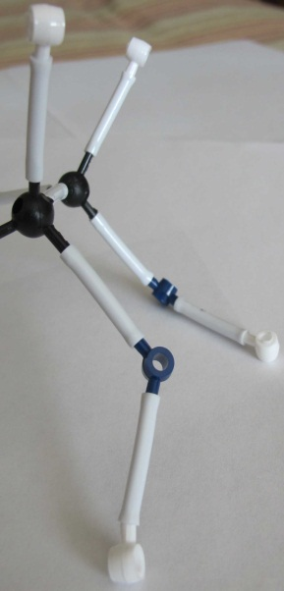
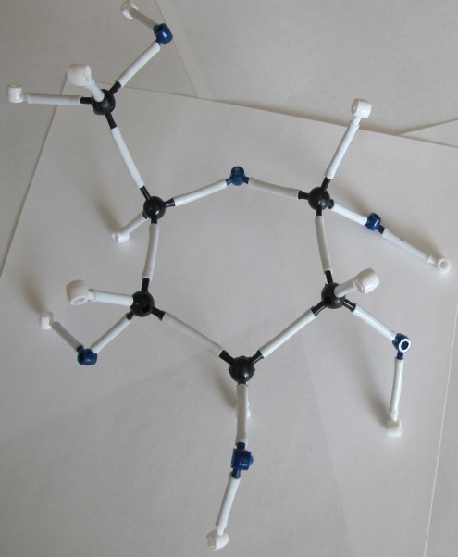
Move to the other four carbons on the ring. Attach 1 oxygen and 1 hydrogen to these carbons. Then attach another hydrogen to each oxygen. Make sure it looks similar to the image on the right.

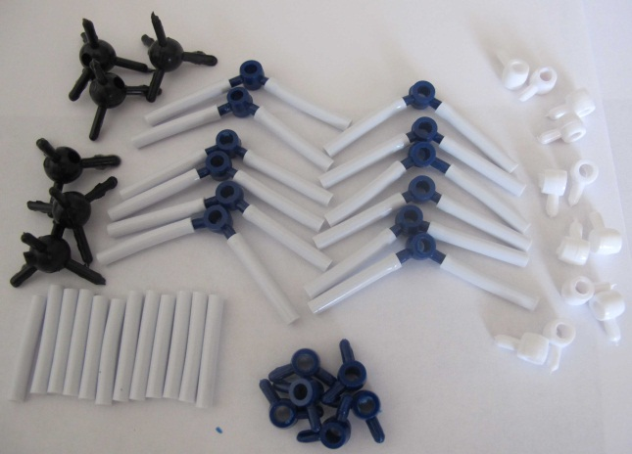
Step 3: Answer Questions About Your Reactants: Look at your glucose and oxygen molecules. Using your worksheet, answer the questions about these two molecules. What atoms do these molecules have, and do they have chemical energy?

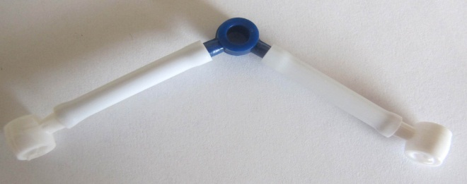
Step 4: Cellular Respiration Happens: In cell respiration, cells break down glucose and oxygen and rearrange the atoms into CO₂ and H₂O. Take apart the glucose molecule and remove 1 oxygen atom from all your oxygen molecules. Leave bonds connected to as many oxygen atoms as possible.

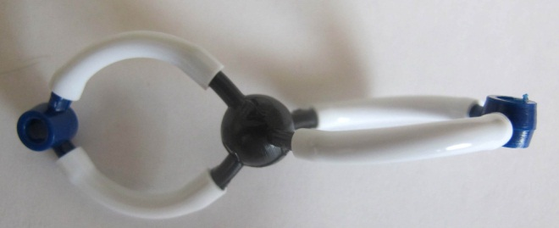
Step 5: Build Your Water Molecules: Water contains 1 oxygen atom and 2 hydrogen atoms. Build 6 of these molecules.

Step 6: Build Your Carbon Dioxide Molecules: Carbon dioxide contains 1 carbon atom and 2 oxygen atoms. There are two bonds between the carbon atom and oxygen atoms (called a “double bond”). Build 6 of these molecules.

Now, answer and discuss the questions on your worksheet.

